Chapter 19, Solution 69.

We first determine the y parameters for the upper network 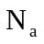.
To get 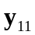 and 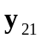, consider the circuit in Fig. (a).

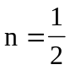, 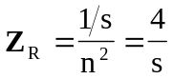

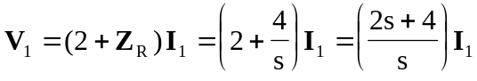
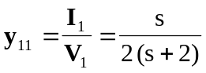

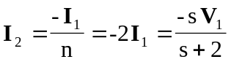
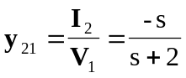

To get 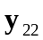 and 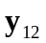, consider the circuit in Fig. (b).
2 : 1
1/s
2 
(b)

I₁
I₂
+
V₁ =0
−
+
V₂
−
I₂

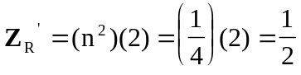

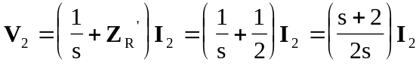

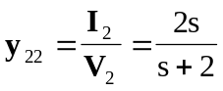

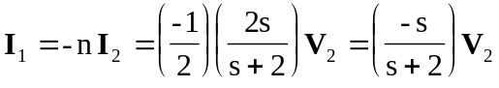

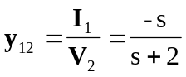

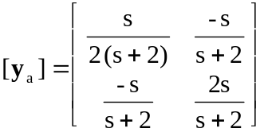

For the lower network 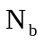, we obtain and by referring to the network in Fig. (c).
s
2
+
−
(c)

I₁
I₂
+
V₂ = 0
−
V₁

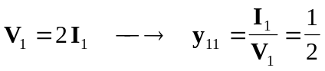

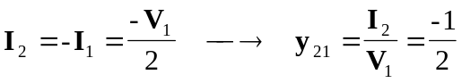

To get and , refer to the circuit in Fig. (d).
s
2
(d)

I₁
I₂
+
V₁ = 0
−
+
V₂
−
I₂

